**MOBILE APPLICATION DEVELOPMENT**

**LAB MANUAL**

**PGM1: GREATEST AMONG THREE NUMBERS**

**XML CODE:**

<androidx.constraintlayout.widget.ConstraintLayout xmlns:android="http://schemas.android.com/apk/res/android"

xmlns:app="http://schemas.android.com/apk/res-auto"

xmlns:tools="http://schemas.android.com/tools"

android:layout_width="match_parent"

android:layout_height="match_parent"

tools:context=".MainActivity">

<EditText

android:id="@+id/num1"

android:layout_width="wrap_content"

android:layout_height="wrap_content"

android:ems="10"

android:inputType="number"

app:layout_constraintBottom_toBottomOf="parent"

app:layout_constraintEnd_toEndOf="parent"

app:layout_constraintHorizontal_bias="0.542"

app:layout_constraintStart_toStartOf="parent"

app:layout_constraintTop_toTopOf="parent"

app:layout_constraintVertical_bias="0.109" />

<EditText

android:id="@+id/num2"

android:layout_width="wrap_content"

android:layout_height="wrap_content"

android:ems="10"

android:inputType="number"

app:layout_constraintBottom_toBottomOf="parent"

app:layout_constraintEnd_toEndOf="parent"

app:layout_constraintHorizontal_bias="0.542"

app:layout_constraintStart_toStartOf="parent"

app:layout_constraintTop_toBottomOf="@+id/num1"

app:layout_constraintVertical_bias="0.035" />

<Button

android:id="@+id/btn"

android:layout_width="wrap_content"

android:layout_height="wrap_content"

android:text="calculate"

app:layout_constraintBottom_toBottomOf="parent"

app:layout_constraintEnd_toEndOf="parent"

app:layout_constraintHorizontal_bias="0.529"

app:layout_constraintStart_toStartOf="parent"

app:layout_constraintTop_toBottomOf="@+id/num2"

app:layout_constraintVertical_bias="0.153" />

<TextView

android:id="@+id/tv"

android:layout_width="275dp"

android:layout_height="100dp"

android:layout_marginTop="32dp"

android:textSize="32sp"

app:layout_constraintEnd_toEndOf="parent"

app:layout_constraintHorizontal_bias="0.535"

app:layout_constraintStart_toStartOf="parent"

app:layout_constraintTop_toBottomOf="@+id/btn"

app:layout_constraintVertical_bias="0.05" />

<EditText

android:id="@+id/num3"

android:layout_width="wrap_content"

android:layout_height="wrap_content"

android:ems="10"

android:inputType="number"

app:layout_constraintBottom_toBottomOf="parent"

app:layout_constraintEnd_toEndOf="parent"

app:layout_constraintHorizontal_bias="0.542"

app:layout_constraintStart_toStartOf="parent"

app:layout_constraintTop_toBottomOf="@+id/num2"

app:layout_constraintVertical_bias="0.035" />

</androidx.constraintlayout.widget.ConstraintLayout>

**JAVA CODE:**

**package** com.example.addingtwonumbers;  
  
**import** androidx.appcompat.app.AppCompatActivity;  
  
**import** android.content.Intent;  
**import** android.os.Bundle;  
**import** android.view.View;  
**import** android.widget.Button;  
**import** android.widget.EditText;  
**import** android.widget.TextView;  
  
**public class** MainActivity **extends** AppCompatActivity {  
  
 **private** EditText **n1**;  
 **private** EditText **n2**;  
 **private** EditText **n3**;  
 **private** Button **calc**;  
 **private** TextView **result**;  
  
  
  
 @Override  
 **protected void** onCreate(Bundle savedInstanceState) {  
 **super**.onCreate(savedInstanceState);  
 setContentView(R.layout.***activity_main***);  
  
 **n1**=(EditText)findViewById(R.id.***num1***);  
 **n2**=(EditText)findViewById(R.id.***num2***);  
 **n3**=(EditText)findViewById(R.id.***num3***);  
  
 **calc**=(Button)findViewById(R.id.***btn***);  
 **result**=(TextView)findViewById(R.id.***tv***);  
  
 **calc**.setOnClickListener(**new** View.OnClickListener() {  
 @Override  
 **public void** onClick(View view) {  
 **int** number1=Integer.*parseInt*(**n1**.getText().toString());  
 **int** number2=Integer.*parseInt*(**n2**.getText().toString());  
 **int** number3=Integer.*parseInt*(**n3**.getText().toString());  
 **if**(number1>number2)  
 **result**.setText(**"Greatest Number is:"**+number1);  
 **else if**(number2 > number3)  
 **result**.setText(**"Greatest Number is:"**+number2);  
 **else  
 result**.setText(**"Greatest Number is:"**+number3);  
 }  
 });  
  
 }  
}

OUTPUT

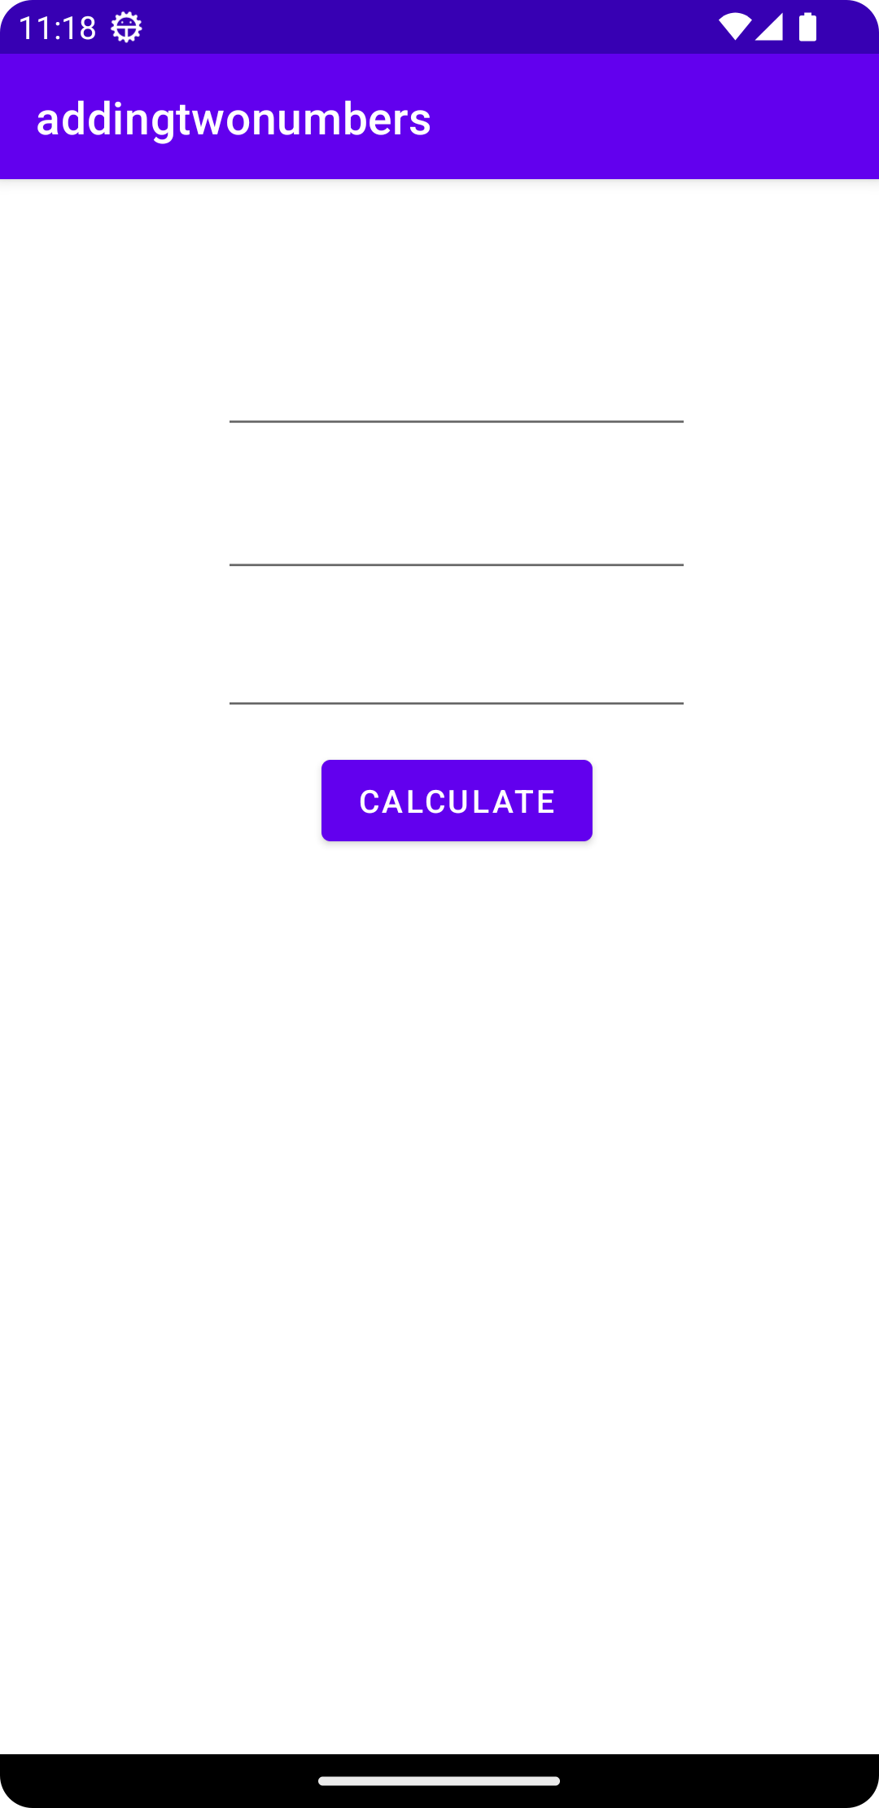 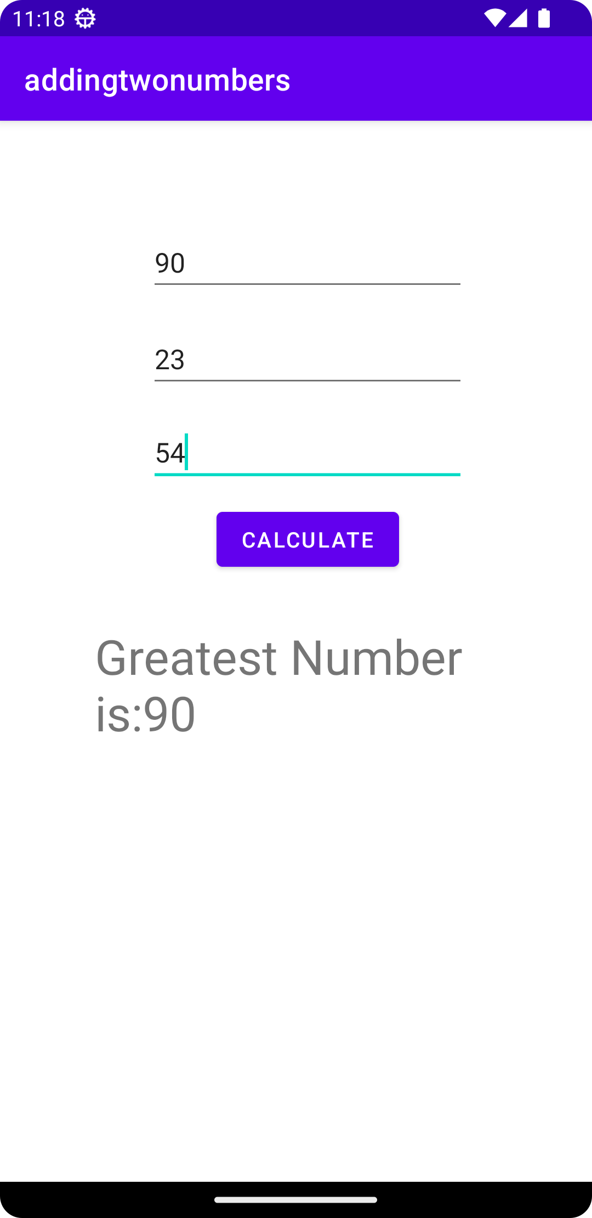

**PGM2: DISPLAYING PERSONAL DETAILS**

**XML CODE:**

**activity_main.xml**

*<?***xml version="1.0" encoding="utf-8"***?>*<**LinearLayout xmlns:android="http://schemas.android.com/apk/res/android"  
 xmlns:app="http://schemas.android.com/apk/res-auto"  
 xmlns:tools="http://schemas.android.com/tools"  
 android:layout_width="match_parent"  
 android:layout_height="match_parent"  
 tools:context=".MainActivity"  
 android:orientation="vertical"  
 android:gravity="center"  
 android:padding="10dp"**>  
  
<**EditText  
 android:id="@+id/nameET"  
 android:hint="Enter Name"  
 android:inputType="text"  
 android:layout_width="match_parent"  
 android:layout_height="wrap_content"**/>  
<**EditText  
 android:id="@+id/emailET"  
 android:hint="Enter EMail"  
 android:inputType="textEmailAddress"  
 android:layout_width="match_parent"  
 android:layout_height="wrap_content"**/>  
<**EditText  
 android:id="@+id/phoneET"  
 android:hint="Enter Phone Number"  
 android:inputType="phone"  
 android:layout_width="match_parent"  
 android:layout_height="wrap_content"**/>  
 <**Button  
 android:id="@+id/saveBtn"  
 android:text="Save"  
 android:layout_width="wrap_content"  
 android:layout_height="wrap_content"**/>  
</**LinearLayout**>

**activity_second.xml**

*<?***xml version="1.0" encoding="utf-8"***?>*<**LinearLayout xmlns:android="http://schemas.android.com/apk/res/android"  
 xmlns:app="http://schemas.android.com/apk/res-auto"  
 xmlns:tools="http://schemas.android.com/tools"  
 android:layout_width="match_parent"  
 android:layout_height="match_parent"  
 android:orientation="vertical"  
 android:gravity="center"  
 android:padding="10dp"  
 tools:context=".secondActivity"**>  
  
 <**TextView  
 android:id="@+id/resultTV"  
 android:layout_width="match_parent"  
 android:layout_height="200dp"  
 android:textSize="30sp"  
 android:textStyle="bold"**/>  
  
</**LinearLayout**>

**JAVA CODE:**

**MainActivity.java**

**package** com.example.personal_details;  
  
**import** androidx.appcompat.app.ActionBar;  
**import** androidx.appcompat.app.AppCompatActivity;  
  
**import** android.content.Intent;  
**import** android.os.Bundle;  
**import** android.view.View;  
**import** android.widget.Button;  
**import** android.widget.EditText;  
  
**public class** MainActivity **extends** AppCompatActivity {  
  
 @Override  
 **protected void** onCreate(Bundle savedInstanceState) {  
 **super**.onCreate(savedInstanceState);  
 setContentView(R.layout.***activity_main***);  
  
 ActionBar actionBar =getSupportActionBar();  
 actionBar.setTitle(**"First Activity"**);  
  
 EditText mNameET=findViewById(R.id.***nameET***);  
 EditText mEmailET=findViewById(R.id.***emailET***);  
 EditText mPhoneET=findViewById(R.id.***phoneET***);  
  
 Button mSaveBtn=findViewById(R.id.***saveBtn***);  
  
 mSaveBtn.setOnClickListener(**new** View.OnClickListener() {  
 @Override  
 **public void** onClick(View view) {  
 *//get data from EditText* String name=mNameET.getText().toString();  
 String email=mEmailET.getText().toString();  
 String phone=mPhoneET.getText().toString();  
  
 *//Intent activity* Intent intent=**new** Intent(MainActivity.**this**,secondActivity.**class**);  
 intent.putExtra(**"NAME"**,name);  
 intent.putExtra(**"EMAIL"**,email);  
 intent.putExtra(**"PHONE"**,phone);  
 startActivity(intent);  
 }  
 });  
  
 }  
}

**secondActivity.java**

**package** com.example.personal_details;  
  
**import** androidx.appcompat.app.ActionBar;  
**import** androidx.appcompat.app.AppCompatActivity;  
  
**import** android.content.Intent;  
**import** android.os.Bundle;  
**import** android.widget.TextView;  
  
**public class** secondActivity **extends** AppCompatActivity {  
  
 @Override  
 **protected void** onCreate(Bundle savedInstanceState) {  
 **super**.onCreate(savedInstanceState);  
 setContentView(R.layout.***activity_second***);  
  
 ActionBar actionBar =getSupportActionBar();  
 actionBar.setTitle(**"Second Activity"**);  
  
 *//intent to get data* Intent intent=getIntent();  
 String name=intent.getStringExtra(**"NAME"**);  
 String email=intent.getStringExtra(**"EMAIL"**);  
 String phone=intent.getStringExtra(**"PHONE"**);  
  
 TextView mResultTY=findViewById(R.id.***resultTV***);  
 mResultTY.setText(**"My Name is: "**+name+**"\nMy EMail ID is: "**+email+**"\nMy Mobile Number is: "**+phone);  
 }  
}

OUTPUT

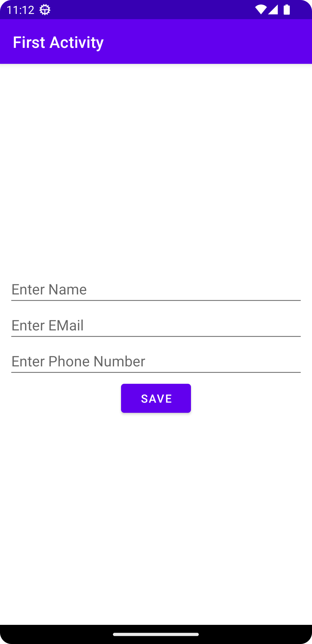 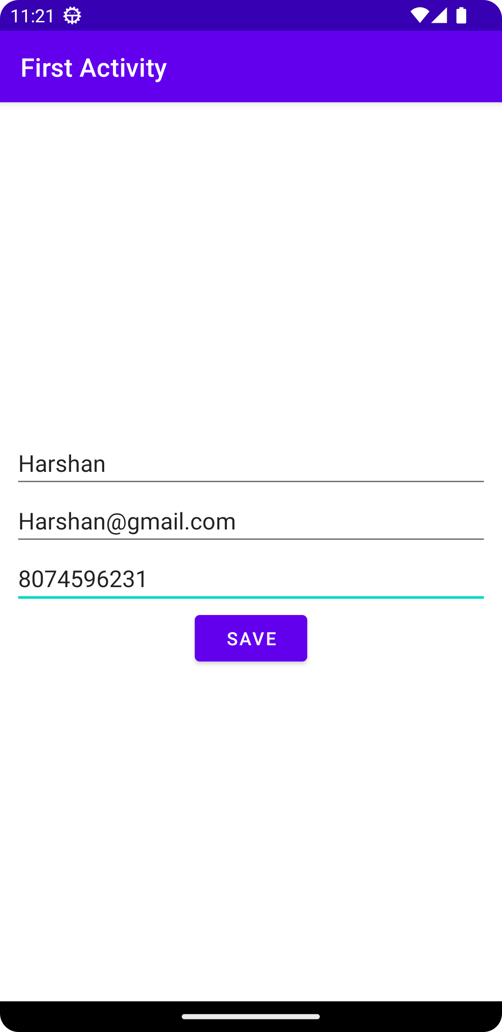 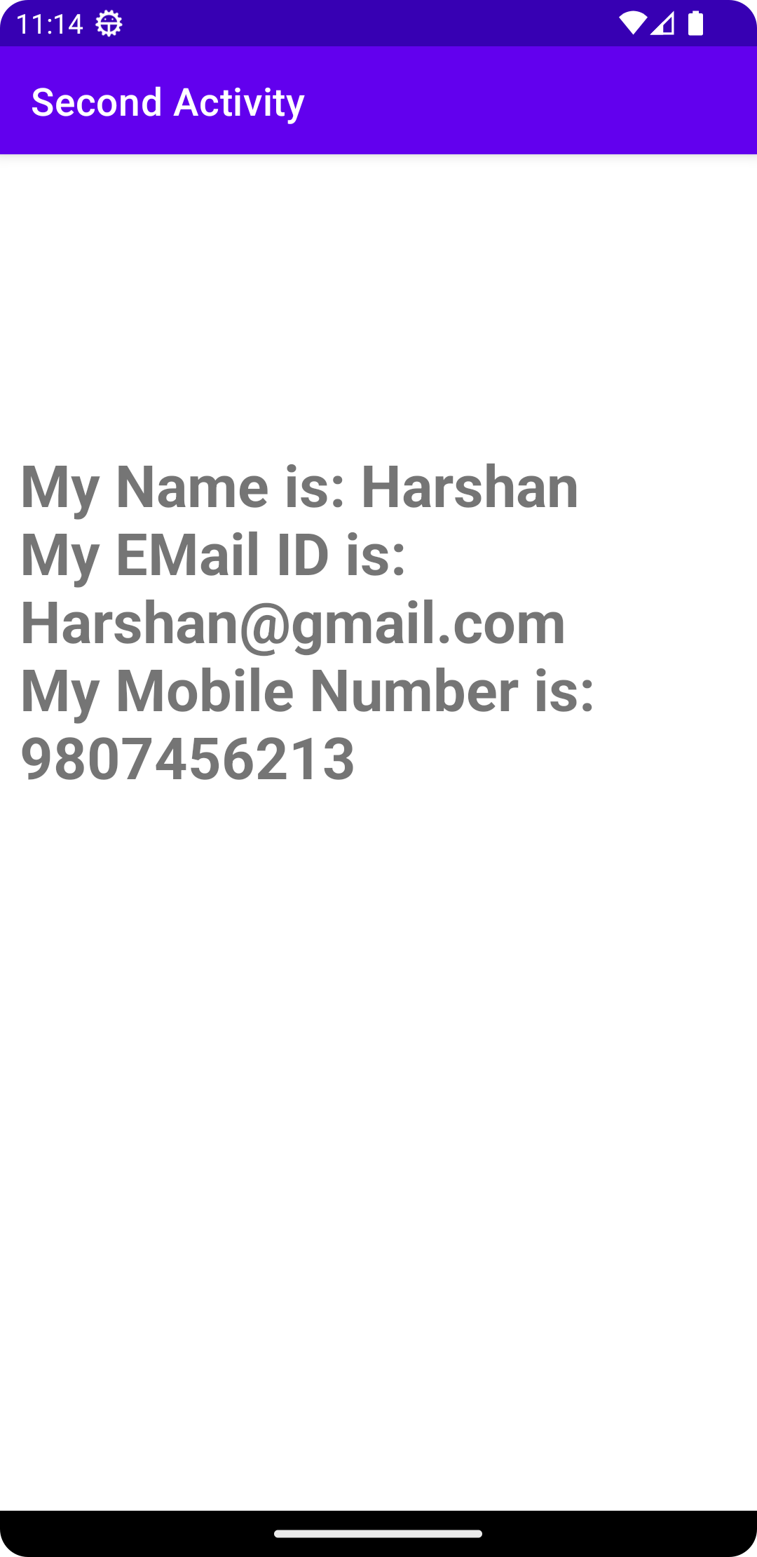

**PGM3: USE OF RADIO BUTTONS**

**XML CODE:**

*<?***xml version="1.0" encoding="utf-8"***?>*<**RelativeLayout  
xmlns:android="http://schemas.android.com/apk/res/android"  
xmlns:app="http://schemas.android.com/apk/res-auto"  
xmlns:tools="http://schemas.android.com/tools"  
android:layout_width="match_parent"  
android:layout_height="match_parent"  
tools:context=".MainActivity"**>  
  
<**TextView  
 android:layout_width="wrap_content"  
 android:layout_height="wrap_content"  
 android:text="Select your Subject ?"  
 android:textStyle="bold"  
 android:layout_marginLeft="10dp"  
 android:textSize="20sp"**/>  
  
*<!-- add RadioGroup which contain the many RadioButton-->*<**RadioGroup  
 android:layout_marginTop="50dp"  
 android:id="@+id/groupradio"  
 android:layout_marginLeft="10dp"  
 android:layout_width="fill_parent"  
 android:layout_height="wrap_content"**>  
  
 *<!-- In RadioGroup create the 1 Radio Button-->  
 <!-- like this we will add some more Radio Button-->* <**RadioButton  
 android:layout_width="fill_parent"  
 android:layout_height="wrap_content"  
 android:id="@+id/radia_id1"  
 android:text="DBMS"  
 android:textSize="20sp"**/>  
  
 <**RadioButton  
 android:layout_width="fill_parent"  
 android:layout_height="wrap_content"  
 android:id="@+id/radia_id2"  
 android:text="C/C++ Programming"  
 android:textSize="20sp"**/>  
  
 <**RadioButton  
 android:layout_width="fill_parent"  
 android:layout_height="wrap_content"  
 android:id="@+id/radia_id3"  
 android:text="Data Structure"  
 android:textSize="20sp"**/>  
  
 <**RadioButton  
 android:layout_width="fill_parent"  
 android:layout_height="wrap_content"  
 android:id="@+id/radia_id4"  
 android:text="Algorithms"  
 android:textSize="20sp"**/>  
</**RadioGroup**>  
  
*<!-- add button For Submit the Selected item-->*<**Button  
 android:layout_width="wrap_content"  
 android:layout_height="wrap_content"  
 android:text="Submit"  
 android:id="@+id/submit"  
 android:textStyle="bold"  
 android:textSize="20sp"  
 android:layout_marginTop="300dp"  
 android:layout_marginLeft="180dp"** />  
  
*<!-- add clear button for clear the selected item-->*<**Button  
 android:layout_width="wrap_content"  
 android:layout_height="wrap_content"  
 android:text="Clear"  
 android:id="@+id/clear"  
 android:textSize="20sp"  
 android:textStyle="bold"  
 android:layout_marginTop="300dp"  
 android:layout_marginLeft="20dp"** />  
  
</**RelativeLayout**>

**JAVA CODE:**

**package** com.example.myapplication;  
  
 **import static** android.widget.Toast.*;  
  
 **import** androidx.appcompat.app.AppCompatActivity;  
 **import** android.os.Bundle;  
 **import** android.view.View;  
 **import** android.widget.Button;  
 **import** android.widget.RadioButton;  
 **import** android.widget.RadioGroup;  
 **import** android.widget.Toast;  
  
 **import** com.example.myapplication.R;  
  
**public class** MainActivity **extends** AppCompatActivity {  
  
 *// Define the object for Radio Group,  
 // Submit and Clear buttons* **private** RadioGroup **radioGroup**;  
 Button **submit**, **clear**;  
  
 @Override  
 **protected void** onCreate(Bundle savedInstanceState)  
 {  
 **super**.onCreate(savedInstanceState);  
 setContentView(R.layout.***activity_main***);  
  
 *// Bind the components to their respective objects  
 // by assigning their IDs  
 // with the help of findViewById() method* **submit** = (Button)findViewById(R.id.***submit***);  
 **clear** = (Button)findViewById(R.id.***clear***);  
 **radioGroup** = (RadioGroup)findViewById(R.id.***groupradio***);  
  
 *// Uncheck or reset the radio buttons initially* **radioGroup**.clearCheck();  
  
 *// Add the Listener to the RadioGroup* **radioGroup**.setOnCheckedChangeListener(  
 **new** RadioGroup  
 .OnCheckedChangeListener() {  
 @Override  
  
 *// The flow will come here when  
 // any of the radio buttons in the radioGroup  
 // has been clicked  
  
 // Check which radio button has been clicked* **public void** onCheckedChanged(RadioGroup group,  
 **int** checkedId)  
 {  
  
 *// Get the selected Radio Button* RadioButton  
 radioButton  
 = (RadioButton)group  
 .findViewById(checkedId);  
 }  
 });  
  
 *// Add the Listener to the Submit Button* **submit**.setOnClickListener(**new** View.OnClickListener() {  
  
 @Override  
 **public void** onClick(View v)  
 {  
  
 *// When submit button is clicked,  
 // Ge the Radio Button which is set  
 // If no Radio Button is set, -1 will be returned* **int** selectedId = **radioGroup**.getCheckedRadioButtonId();  
 **if** (selectedId == -1) {  
 *makeText*(MainActivity.**this**, **"No answer has been selected"**, ***LENGTH_SHORT***).show();  
 }  
 **else** {  
  
 RadioButton radioButton  
 = (RadioButton)**radioGroup** .findViewById(selectedId);  
  
 *// Now display the value of selected item  
 // by the Toast message  
 makeText*(MainActivity.**this**, radioButton.getText(), ***LENGTH_SHORT***).show();  
 }  
 }  
 });  
  
 *// Add the Listener to the Submit Button* **clear**.setOnClickListener(**new** View.OnClickListener() {  
  
 @Override  
 **public void** onClick(View v)  
 {  
  
 *// Clear RadioGroup  
 // i.e. reset all the Radio Buttons* **radioGroup**.clearCheck();  
 }  
 });  
 }  
}

OUTPUT

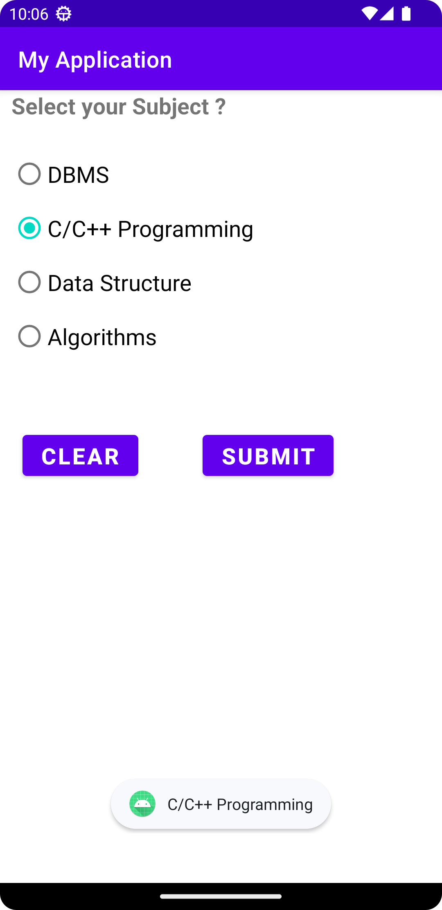

**PGM4: USE OF IMAGE BUTTON**

**XML CODE:**

*<?***xml version="1.0" encoding="utf-8"***?>*<**LinearLayout xmlns:android="http://schemas.android.com/apk/res/android"  
 xmlns:app="http://schemas.android.com/apk/res-auto"  
 xmlns:tools="http://schemas.android.com/tools"  
 android:layout_width="match_parent"  
 android:layout_height="match_parent"  
 android:orientation="vertical"  
 tools:context=".MainActivity"**>  
  
 <**ImageButton  
 android:id="@+id/ImageBtn"  
 android:layout_width="300dp"  
 android:layout_height="90dp"  
 android:layout_gravity="center"  
 android:layout_marginTop="200dp"  
 android:src="@drawable/panda"** />  
  
  
</**LinearLayout**>

**JAVA CODE:**

**package** com.example.image_button;  
  
**import** androidx.appcompat.app.AppCompatActivity;  
  
**import** android.os.Bundle;  
**import** android.view.View;  
**import** android.widget.ImageButton;  
**import** android.widget.Toast;  
  
**public class** MainActivity **extends** AppCompatActivity {  
ImageButton **img**;  
 @Override  
 **protected void** onCreate(Bundle savedInstanceState) {  
 **super**.onCreate(savedInstanceState);  
 setContentView(R.layout.***activity_main***);  
  
 **img**=findViewById(R.id.***ImageBtn***);  
 **img**.setOnClickListener(**new** View.OnClickListener() {  
 @Override  
 **public void** onClick(View view) {  
 Toast.*makeText*(getApplicationContext(),**"Image Button is Clicked"**, Toast.***LENGTH_LONG***).show();  
 *//Toast.makeText(MainActivity.this,"Image Button is Clicked", Toast.LENGTH_LONG.show());* }  
 });  
 }  
}

OUTPUT

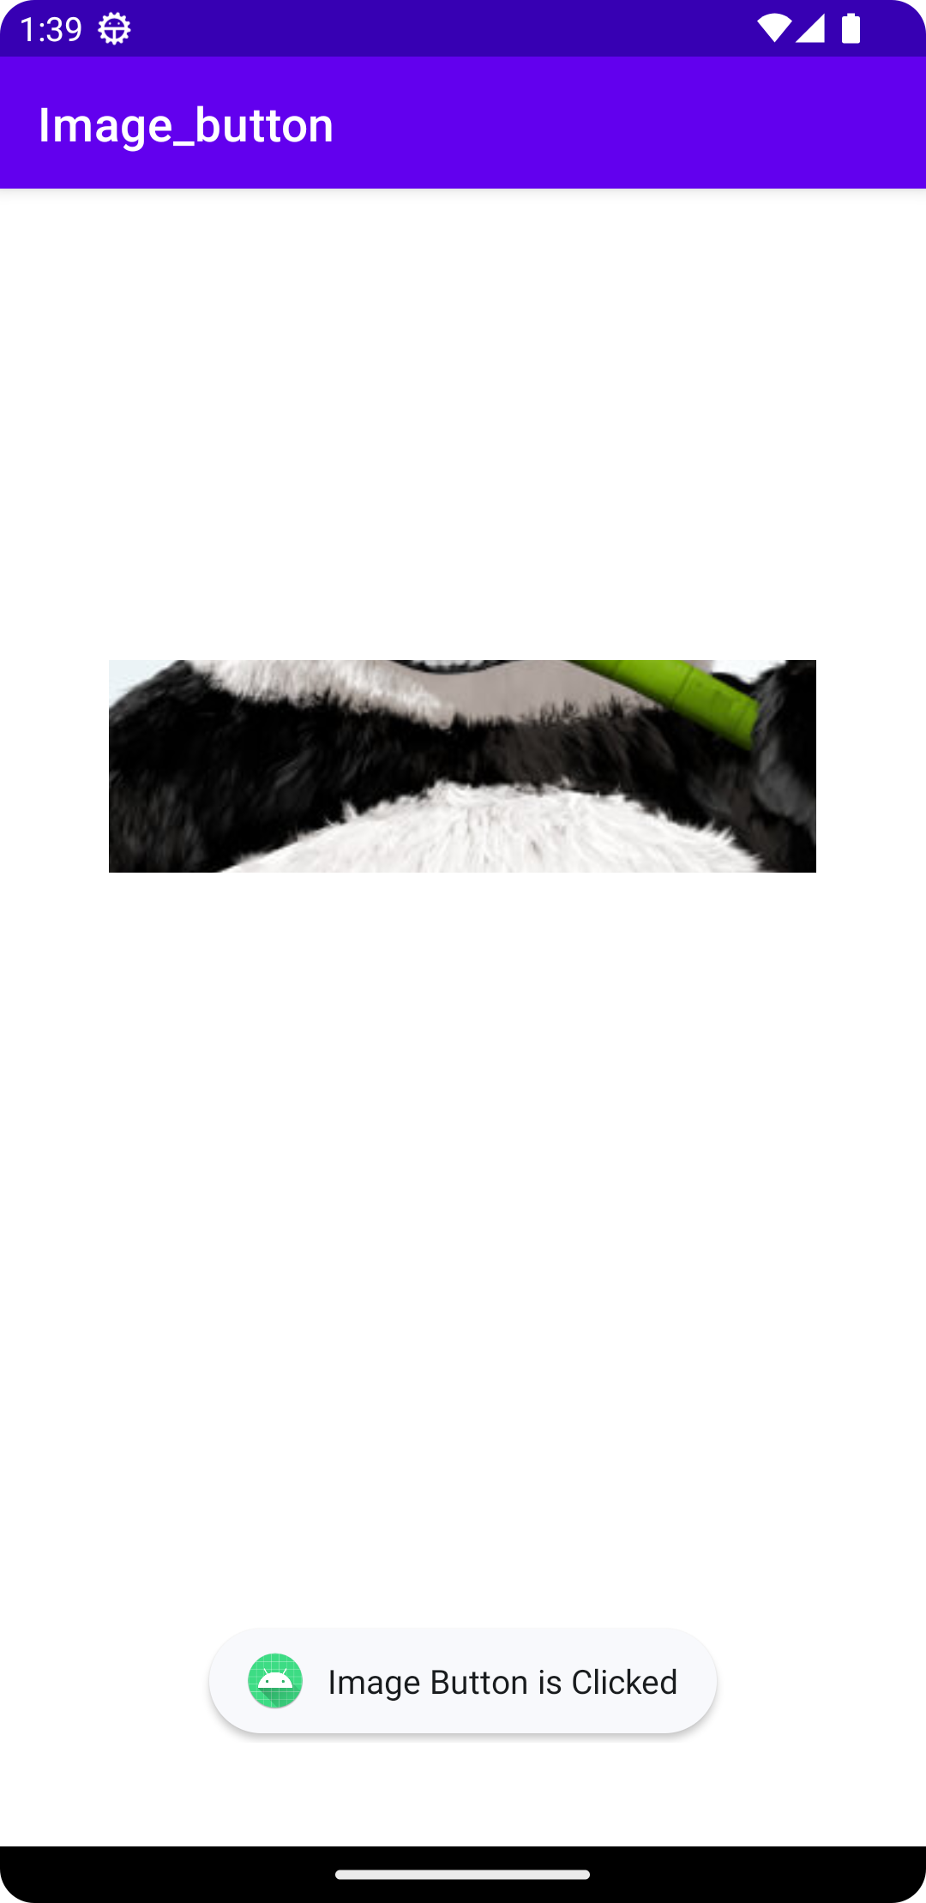

PGM7: USE OF AUDIO MODE

XML code

*<?***xml version="1.0" encoding="utf-8"***?>*<**LinearLayout android:layout_width="match_parent"  
 android:layout_height="match_parent"  
 xmlns:android="http://schemas.android.com/apk/res/android"  
 android:orientation="vertical"**>  
 <**Button  
 android:layout_width="match_parent"  
 android:layout_height="100dp"  
 android:id="@+id/bt1"  
 android:text="CURRENT MODE CHECK"  
 android:onClick="onMode"**/>  
 <**Button  
 android:layout_width="match_parent"  
 android:layout_height="100dp"  
 android:id="@+id/bt2"  
 android:text="RINGER MODE"  
 android:onClick="onRing"**/>  
 <**Button  
 android:layout_width="match_parent"  
 android:layout_height="100dp"  
 android:id="@+id/bt3"  
 android:text="SILENT MODE"  
 android:onClick="onSilent"**/>  
 <**Button  
 android:layout_width="match_parent"  
 android:layout_height="100dp"  
 android:id="@+id/bt4"  
 android:text="VIBRATE MODE"  
 android:onClick="onVibrate"**/>  
  
</**LinearLayout**>

Java code

**package** com.example.audio_phone;  
  
**import** android.content.Context;  
**import** android.media.AudioManager;  
**import** android.os.Bundle;  
**import** android.view.View;  
**import** android.widget.Toast;  
  
**import** androidx.appcompat.app.AppCompatActivity;  
  
**public class** MainActivity **extends** AppCompatActivity {  
  
 **private** AudioManager **myAudioManager**;  
  
 */** Called when the activity is first created. */* @Override  
 **public void** onCreate(Bundle savedInstanceState) {  
 **super**.onCreate(savedInstanceState);  
 setContentView(R.layout.***activity_main***);  
  
 **myAudioManager** = (AudioManager)getSystemService(Context.***AUDIO_SERVICE***);  
 }  
 **public void** onMode(View v)  
 {  
 **int** mod=**myAudioManager**.getRingerMode();  
  
 **if**(mod==AudioManager.***RINGER_MODE_VIBRATE***){  
 Toast.*makeText*(**this**,**"Now in Vibrate Mode"**,Toast.***LENGTH_LONG***).show();  
 }  
  
 **else if**(mod==AudioManager.***RINGER_MODE_NORMAL***){  
 Toast.*makeText*(**this**,**"Now in Ringing Mode"**,Toast.***LENGTH_LONG***).show();  
 }  
  
 **else** {  
 Toast.*makeText*(**this**,**"Now in Silent Mode"**,Toast.***LENGTH_LONG***).show();  
 }  
 }  
 **public void** onRing(View v)  
 {  
 **myAudioManager**.setRingerMode(AudioManager.***RINGER_MODE_NORMAL***);  
 Toast.*makeText*(**this**,**"Now in Ringing Mode"**,Toast.***LENGTH_LONG***).show();  
 }  
 **public void** onSilent(View v)  
 {  
 **myAudioManager**.setRingerMode((AudioManager.***RINGER_MODE_SILENT***));  
 Toast.*makeText*(**this**,**"Now in silent Mode"**,Toast.***LENGTH_LONG***).show();  
 }  
 **public void** onVibrate(View v)  
 {  
 **myAudioManager**.setRingerMode(AudioManager.***RINGER_MODE_VIBRATE***);  
 Toast.*makeText*(**this**,**"Now in Vibrate Mode"**,Toast.***LENGTH_LONG***).show();  
 }  
}

OUTPUT

